**Assignment X**

1. Which customers live in New Jersey? List each customer’s last name, first name, and state.

**Answer:**

Either type the query or copy it from MS Management Studio and paste it here

SELECT lastname, firstname, state

FROM customers

WHERE state = 'NJ';

Place a screenshot of the output below your code

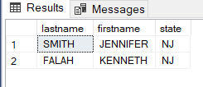**-**

1. Which orders shipped after April 1, 2009? List each order number and the date it shipped.

**Answer:**

SELECT orderid, shipdate

FROM orders

WHERE shipdate > '2009-04-01';

